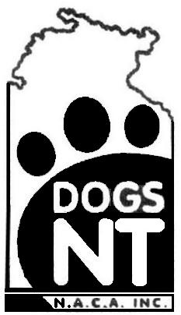
North Australian Canine Association (Inc)
A member Body of the Australian National Kennel Council
PO Box 37521, Winnellie NT 0821 Ph: 8984 3570 Fax: 8984 3409
Email:admin@dogsnt.com.au website: dogsnt.com.au
CONFORMATION JUDGES
APPROVAL TO JUDGE
RENEWAL

I request that my name be retained on the Panel of Conformation Judges for for:

ALL BREEDS
OR GROUPS (One) (Two) (Three) (Four) (Five) (Six) (Seven)
(Indicate Groups Applicable)

APPLICATION FOR APPROVAL AS A TRAINEE CONFORMATION JUDGE
I hereby apply for approval as a Trainee Judge for the following Group(s) for the year commencing 1st January, .

Group(s) | AND
Current prices for this application are available on our web site or from the office.

My remittance of $ covering the following fee is enclosed.

APPLICANT NAME: | M'SHIP No:

RESIDENTIAL ADDRESS | SUBURB |  | POSTCODE
POSTAL ADDRESS | SUBURB |  | POSTCODE
TELEPHONE (Home) |  | TELEPHONE (Bus/Mobile)
SIGNATURE: |  | DATE:
Rule 5.1.7: All Approvals shall expire on the thirty first (31st) day of December of each year (subject to 5.1.9). Judges will be requested to pay both membership and judges renewal fees in advance to permit the early preparation of the ANKC Judges Lists for the following year.

